**Лабораторна робота 5**

**Завдання 1**

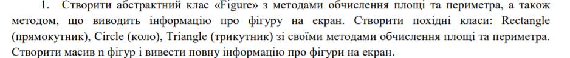

using System;

namespace lab5

{

abstract class Figure

{

abstract public void Show();

abstract public double Param();

abstract public double Plosh();

}

class Program

{

static void Main()

{

Rectangle rec1 = new Rectangle();

Triangle tri1 = new Triangle();

Circle cir1 = new Circle();

Console.WriteLine("Enter a, b of rectangle");

rec1.a = int.Parse(Console.ReadLine());

rec1.b = int.Parse(Console.ReadLine());

rec1.Show();

double par;

par= rec1.Param();

double pl;

pl = rec1.Plosh();

Console.WriteLine("Parametr={0}", par);

Console.WriteLine("Plosh={0}", pl);

Console.WriteLine("Enter a, b, c of tiangle");

tri1.a = int.Parse(Console.ReadLine());

tri1.b = int.Parse(Console.ReadLine());

tri1.c = int.Parse(Console.ReadLine());

par = tri1.Param();

pl = tri1.Plosh();

Console.WriteLine("Parametr={0}", par);

Console.WriteLine("Plosh={0}", pl);

Console.WriteLine("Enter r of circle");

cir1.r = int.Parse(Console.ReadLine());

par =cir1.Param();

pl = cir1.Plosh();

Console.WriteLine("Parametr={0}", par);

Console.WriteLine("Plosh={0}", pl);

}

}

}

Похідні класи

using System;

namespace lab5

{

class Circle: Figure

{

public int r;

public override void Show()

{

Console.WriteLine("r={0}", r);

}

public override double Param()

{

return 2*Math.PI*r;

}

public override double Plosh()

{

return Math.PI*r*r;

}

}

}

using System;

namespace lab5

{

class Rectangle: Figure

{

public int a;

public int b;

public override void Show()

{

Console.WriteLine("a={0}, b={1}", a, b);

}

public override double Param()

{

return a + b;

}

public override double Plosh()

{

return a * b;

}

}

}

using System;

namespace lab5

{

class Triangle: Figure

{

public int a;

public int b;

public int c;

public override void Show()

{

Console.WriteLine("a={0}, b={1}, c={2}", a, b, c);

}

public override double Param()

{

return a + b+c;

}

public override double Plosh()

{

return Math.Sqrt(((a+b+c)/2)*(((a + b + c) / 2)-a)*(((a + b + c) / 2)-b)*(((a + b + c) / 2)-c));

}

}

}

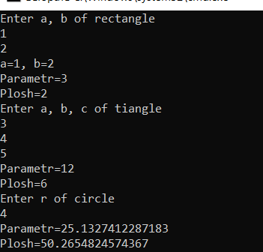

**Завдання 2**

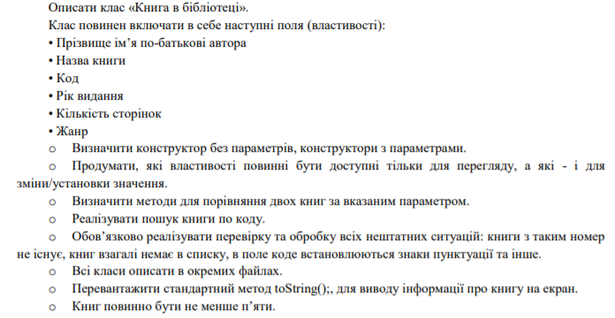

**Клас Book**

namespace lab5._2

{

class Books

{

private string fio;

private string name;

private string code;

private int year;

private int pages;

private string type;

public Books()//конструктор без параметров

{ }

public Books (string fio, string name, string code, int year,

int pages, string type)

{

this.fio = fio;

this.name = name;

this.code = code;

this.year = year;

this.pages = pages;

this.type = type;

}

public string Fio => fio;

public string Name => name;

public int Year => year;

public int Pages => pages;

public string Type => type;

public string Code

{

get => code;

set => code = value;

}

bool EqByFio(Books books)

{

return this.fio.Equals(books.fio);

}

bool EqByName(Books books)

{

return this.name.Equals(books.name);

}

bool EqByYear(Books books)

{

return this.year.Equals(books.year);

}

bool EqBypages(Books books)

{

return this.pages.Equals(books.pages);

}

bool EqBytype(Books books)

{

return this.type.Equals(books.type);

}

bool EqByCode(Books books)

{

return this.code.Equals(books.code);

}

public override string ToString()

{

return $"\n{nameof(fio)}: {fio}, {nameof(name)}: {name}, {nameof(code)}:" +

$" {code}, {nameof(year)}: {year}, {nameof(pages)}: {pages}, {nameof(type)}: {type}";

}

}

}

**Program**

using System;

using System.Collections.Generic;

namespace lab5._2

{

class Program

{

static List<Books> books = new List<Books>();

private static void SearchbyCode(string code)

{

if(books.Count==0)

{

Console.WriteLine("No books found");

return;

}

Books book = books.Find(Book => code.Equals(Book.Code));

Console.WriteLine($"Book with code: {code}" + book.ToString());

}

public static void Main(string[] args)

{

Console.WriteLine("Finding by code");

SearchbyCode("M-141");

books.Add(new Books("Petrov", "Poems", "I-123", 1820, 300, "Poem"));

books.Add(new Books("Cambridge", "English", "E-001", 2020, 120, "Studying"));

books.Add(new Books("Schevchenko", "Kobzar", "I-123", 1820, 300, "Poem"));

books.Add(new Books("Ivanov", "Autos", "M-141", 2018, 120, "Magazine"));

books.Add(new Books("SumDU", "Math", "S-99", 2001, 270, "Studying"));

Console.WriteLine("Finding by code");

SearchbyCode("M-141");

Console.WriteLine("Finding by code");

SearchbyCode("S-99");

}

}

}

